WHAT IS OPERATING SYSTEM 
- Os is the main part of the entire system.
- It is a intermediate distance between the user and the hardware.
- and it helps in the task such as
- Process management
- Memory management
- File handling
- Device control

TYPES OF OPERATING SYSTEM
It has two types: -
- Cli (command line interface)
Example: - Linux
- GUI (graphical user interface)
Example: - windows
------------------------------------------------------------------------------------------------------------------------------------
HISTORY OF UNIX
- In 1964 ------> started project by Bella labs (new jersey)
- In 1969 ------> stopped the project
- In 1969 ------> Restarted by Dennis Ritche and ken Thompson developed a multiuser
multitasking os called UNICS
UNICS: Uniplexed Information and Computing Service
- In 1975 ------> its version 6 more popular and multiple companies create their
own os versions based on unix
NOTE:
- UNICS later renamed to UNIX
- Dennis Ritchie developed the C programming language at Bell Labs in 1972.

UNIX FLAVORS
- IBM --------------> AIX
- HP ---------------> UX
- Apple -----------> MacOS
- Sun Microsystem ----> solaria's

HISTORY OF LINUX
- In 1983 ------> American engineer Richard Stallman started project GNU project
- In 9185 ------> FSF started (free software foundation)
- In 1991 ------> started Programmes like debugger shell, editor
- In 1991 ------> Finnish software engineer Linux Torvalds develops the Kernal
Kernal ----> a core part of operating system
- Kernal + GNU project ----> complete Linux os
- Linux name also came from the engineer Linus Torvalds

LINUX DISTRIBUTIONS
- RedHat
- Debian
- Fedora
- Others
- Centos
- Ubuntu
- Kali linux
- Amazon linux

--------------------------------------------------------------------------------------------------------------------------------------
LINUX CHARACTERSTICS
- Free and Open source
- Secure
- Light weight hardware
- Portable
- Multiuser multitasking

LINUX ARCHITECTURE

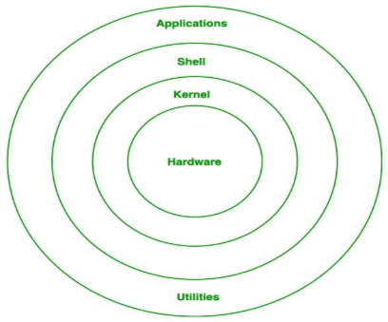

Hardware
- Hardware is a physical component or logical component of any electronic device that Stores the data and run the written code provided by the software.
- Example: keyboard, mouse, monitor, CPU

Kernal
- Kernal is a core part of os
- And has a complete control over everything in the system
- And its a main layer between the hardware and the Software and performs the task such as process management, memory management and file management

Shell
- shell is a Linux command line interpreter
- It provides an interface distance between the user and the kernel
- it can simply convert the users high level command into the low-level code (to understand the kernel)
- Example: bash, ksh, zsh, sh

Software
Software is a set of instructions or collection of command that tells the computer how to perform a particular task

Firmware
Firmware is also a set of instructions written in a machine language which are used to operate the hardware

What is Server
A server is a system (physical machine) that stores the data, runs applications, and provides services to client machines over a network, usually identified by a static IP address.

Desktop OS vs Server OS

Desktop OS
1. A Desktop Operating System is designed for individual users to perform daily tasks.
2.Example: - windows, ubuntu, macOS

Server OS
1. A Server Operating System is designed to manage resources and serve multiple clients over a
network.
2.Example: - Ubuntu server, windows server, Redhat

DEFFERENCE BETWEEN THE WINDOWS / LINUX / UNIX
WINDOWS: -
1.Its a proprietary based (means licensing is required for using windows)
2.it is less secure (more targeted by viruses)
3.it has a heavy hardware (means requires more system resources (RAM/CPU)
4.it is 80% on desktop
5.it is easy to use because of its GUI based
UNIX: -
1.It’s a proprietary based (means licensing is required to use)
2.it is more secure
3.it has a lightweight hardware
4.it is 90% on approx. servers
5.it is hard to use because of its CLI based
LINUX: -
1.It’s a community based, Free and open-source operating system
2.it is more secure
3.it has a lightweight hardware
4.it is 90% on approx. servers
5.it is hard to use because of its CLI based

WHAT IS LINUX
Linux is a free and open-source kernel that provides the stability, Security, multiuser multitasking capabilities and supports the wide range of hardware’s.

PLATFORMS TO USE LINUX
- Labex.io
- Ubuntu (WSL on windows)
- AWS ec2
- Virtual Machine (VirtualBox)

